Problem: A customer has a network either without a DHCP server, or the DHCP server is not able to assign an IP address to a SafeCom controller.
Or the assigned IP. Address of the SafeCom controller can not be identified.
This makes it impossible to use the SafeCom controller, as the IP address is not known. As the IP. Address is not known, is is not possible to assign a known fixed IP. Address to the SafeCom controller using the ordinary way of accessing the Controllers embedded webserver via an Internet Browser.

Solution: Reset the Controller to factory default. While the controller is trying to obtain an IP. Address, make a manual ARP entry for the controller on your computer assigning a temporary manual IP. Address. Then open the embedded webserver of the Controller connecting to the temporary manual IP. Address using an Internet browser.

Example:
SafeCom controller has MAC. Address 00-C0-76-FF-0A-DD
Temporary manual IP. Address 172.16.6.58 is being used. (This address is currently not being used by other network devices)
Your computer being used, is located in the same subnet as the temporary IP address.

- While the SafeCom Controller is powered on, press and hold the testbutton depressed on the SafeCom controller.
- First all 4 leds will blink, but after a while, only the LAN led blinks.
- Open a command prompt on the computer
- Ping the temporary IP. Address to make sure it is not currently being used by other devices.
- In the command line write:
C:\>arp -s 172.16.6.58 00-C0-76-FF-0A-DD <ENTER>
- Then write:
C:\>ping 172.16.6.58 <ENTER>
(you should not expect to get a reply back)
Pinging 172.16.6.58 with 32 bytes of data:
Request timed out.
Request timed out.
Request timed out.
Reply from 172.16.6.58: bytes=32 time<1ms TTL=31
- Now from your Internet Browser, connect to http://172.16.6.58
On the Embedded webpage, choose “Advanced configuration”, then “TCP/IP”
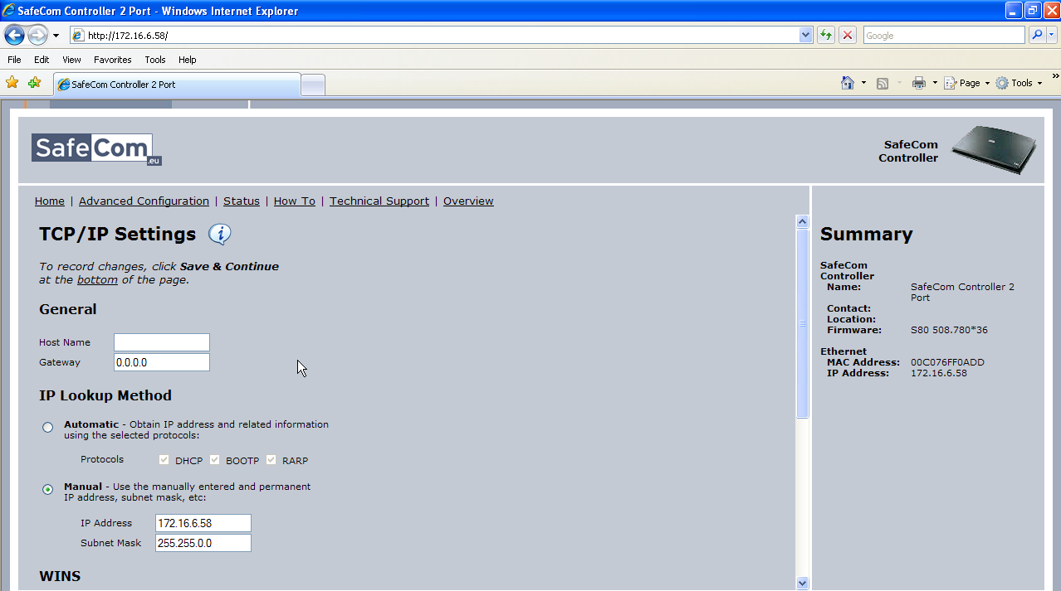
Now you are able to type in a permanent fixed IP. Adr. For the Controller.
Remember to choose a subnet mask, that allows the Controller to “See” and connect to the SafeCom server and attached printers IP. Adr.
Remember to fill in a Gateway IP. Adr. aswell as DNS and WINS server entries.
- When done press “Save and continue”, then click “Restart”, then the “Restart” button.
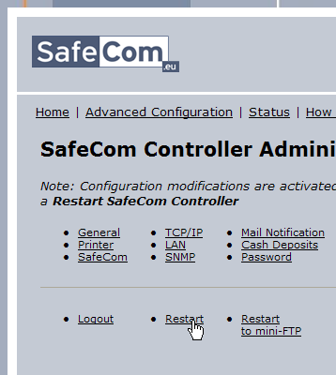
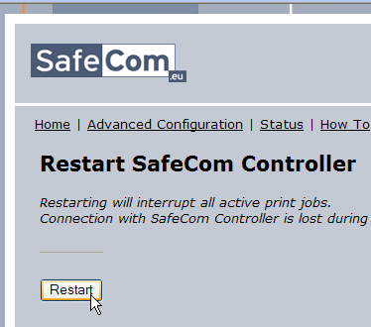
- Now you will be able to use the SafeCom controller, and if needed reconfigure it.
- Remember to remove the arp entry for the temporary IP address from you computer.
From a command prompt:
C:\>arp -d 172.16.6.58 <ENTER>
Verify that the arp entry has been deleted:
C:\>arp –a <ENTER>

